MATLAB CODE SIGNALS AND

SYSTEMS-1

Supreet

January 25, 2019

**Objective: -**

1. Generation of different signals and exploration of different functions related to signals processing in MATLAB
2. Perform basic operations on the signals

**Requirements: -**

1. MATLAB software

**Theory: -**

A **signal** is a function that "conveys information about the behaviour or attributes of some phenomenon". A **signal** may also be defined as an "observable change in a quantifiable entity".

In MATLAB a signal can be represented by a vector on n-dimension. The signal the thus generated here are discrete in nature. The signals are linked to a function which provides the corresponding values of the signal to the time vector.

Some basic operations on signals that have been performed as a part of this experiment are:-

1. **Shifting**: - Shifting means movement of the **signal**, either in time domain (around Y-axis) or in amplitude domain (around X-axis). Accordingly, we can classify the **shifting** into two categories named as Time **shifting** and Amplitude **shifting**
2. **Scaling**: - **Scaling** of a **signal** means, a constant is multiplied with the time or amplitude of the **signal**.
3. **Reversal: -** Whenever the **time** in a **signal** gets multiplied by -1, the **signal** gets **reversed**. It produces its mirror image about Y or X-axis. This is known as **Reversal** of the **signal.**
4. **Addition: - Addition** of two **signals** is nothing but **addition** of their corresponding amplitudes. 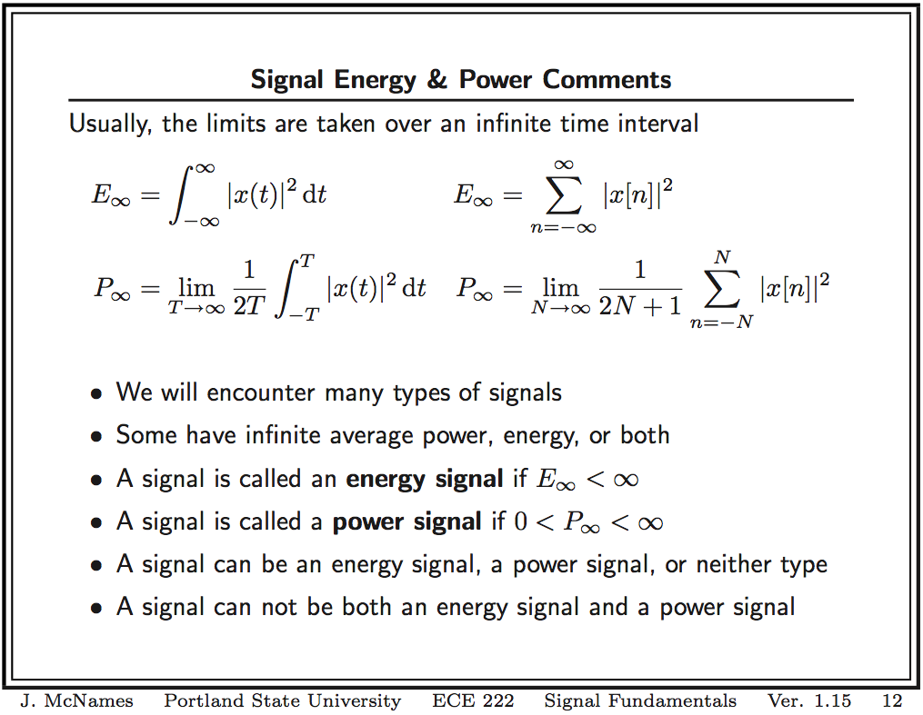

**CODE:-**

clc;  
fs = 0.1;  
t = 0:0.01:20;  
t1 = 0:0.1:-20;  
N = 100;  
n = 0:1:N-1;  
tt = -50:50;  
l = length(tt)/2;  
  
  
  
fun_x1 = @(x) sin(2*pi*x*fs);  
x1 = fun_x1(t);  
fun_x2 = @(x) 0.2.^x;  
x2 = fun_x2(n);  
fun_x3 = @(x) 0.9.^x;  
x3 = fun_x3(n);  
fun_x5 = @(x) imp1(x);  
x5 = imp1(t);  
fun_x4 = @(x) step1(x);  
x4 = step1(t);  
fun_x6 = @(x) ramp1(x);  
x6 = ramp1(t);  
fun_x7 = @(x) step1(x)+step1(-x);  
x7 = fun_x7(t);  
subplot(3,3,1)  
plot(t,x1,'y');  
xlabel('Time (sec)');  
ylabel('Amplitude') ;  
title('Sine');  
subplot(3,3,2);  
plot(n,x2)  
xlabel('Time (sec)');  
ylabel('Amplitude') ;  
title('0.2^n');  
subplot(3,3,3);  
plot(n,x3)  
xlabel('Time (sec)');  
ylabel('Amplitude') ;  
title('0.9^n');  
subplot(3,3,4);  
plot(t,x4)  
xlabel('Time (sec)');  
ylabel('Amplitude') ;  
title('unit step');  
subplot(3,3,5);  
plot(t,x5)  
xlabel('Time (sec)');  
ylabel('Amplitude') ;  
title('unit impulse');  
subplot(3,3,6);  
plot(t,x6)  
xlabel('Time (sec)');  
ylabel('Amplitude') ;  
title('unit ramp');  
subplot(3,3,7);  
plot(t,x7);  
xlabel('Time (sec)');  
ylabel('Amplitude') ;  
title('x7');  
x23 = x2+x3;  
subplot(3,3,8);  
plot(n,x23);  
xlabel('Time (sec)');  
ylabel('Amplitude') ;  
title('x2+x3');  
  
X = sprintf('enrygy of x1 = ');  
disp(X)  
%e1 = integral((fun_x1).^2,-Inf,Inf)  
e1 = norm((x1).^2)  
  
X = sprintf('power of x1 = ');  
disp(X)  
p1 = norm((x1).^2)/length(x1)  
  
X = sprintf('enrygy of x2 = ');  
disp(X)  
%e1 = integral((fun_x1).^2,-Inf,Inf)  
e1 = norm((x2).^2)  
  
X = sprintf('power of x2 = ');  
disp(X)  
p1 = norm((x2).^2)/length(x2)  
  
X = sprintf('enrygy of x3 = ');  
disp(X)  
%e1 = integral((fun_x1).^2,-Inf,Inf)  
e1 = norm((x3).^2)  
  
X = sprintf('power of x1 = ');  
disp(X)  
p1 = norm((x3).^2)/length(x3)  
  
X = sprintf('enrygy of x4 = ');  
disp(X)  
%e1 = integral((fun_x1).^2,-Inf,Inf)  
e1 = norm((x4).^2)  
  
X = sprintf('power of x4 = ');  
disp(X)  
p1 = norm((x4).^2)/length(x4)  
  
X = sprintf('enrygy of x5 = ');  
disp(X)  
%e1 = integral((fun_x1).^2,-Inf,Inf)  
e1 = norm((x5).^2)  
  
X = sprintf('power of x5 = ');  
disp(X)  
p1 = norm((x5).^2)/length(x5)  
  
X = sprintf('enrygy of x6 = ');  
disp(X)  
%e1 = integral((fun_x1).^2,-Inf,Inf)  
e1 = norm((x6).^2)  
  
X = sprintf('power of x6 = ');  
disp(X)  
p1 = norm((x6).^2)/length(x6)  
  
X = sprintf('enrygy of x7 = ');  
disp(X)  
%e1 = integral((fun_x1).^2,-Inf,Inf)  
e1 = norm((x7).^2)  
  
X = sprintf('power of x7 = ');  
disp(X)  
p1 = norm((x7).^2)/length(x7)  
  
figure;  
plot(t,x1,'y');  
hold on;  
x1t = sin(4*pi*t*fs);  
plot(t,x1t,'r');  
hold on;  
x1a = 2*sin(2*pi*t*fs);  
plot(t,x1a, 'c');  
x1th = sin(2*pi*t*fs+pi/3);  
plot(t,x1th,'g');  
hold on;  
x1ah = sin(2*pi*t*fs)+1;  
plot(t,x1ah,'k');  
hold on;  
x1ar = -sin(2*pi*t*fs);  
plot(t,x1ar,'m');  
hold on;  
x1tr = sin(2*pi*(-t)*fs);  
plot(t,x1tr,'b');  
hold on;  
xlabel('Time (sec)');  
ylabel('Amplitude') ;  
title('Sine');  
legend('original','time scaliing', 'amplitude scalling', 'time shifting', 'amplitude scalling','amplitude reversal','time reversal');

enrygy of x1 =   
  
e1 =  
  
 27.3861  
  
power of x1 =   
  
p1 =  
  
 0.0137  
  
enrygy of x2 =   
  
e1 =  
  
 1.0008  
  
power of x2 =   
  
p1 =  
  
 0.0100  
  
enrygy of x3 =   
  
e1 =  
  
 1.7052  
  
power of x1 =   
  
p1 =  
  
 0.0171  
  
enrygy of x4 =   
  
e1 =  
  
 44.7325  
  
power of x4 =   
  
p1 =  
  
 0.0224  
  
enrygy of x5 =   
  
e1 =  
  
 1  
  
power of x5 =   
  
p1 =  
  
 4.9975e-04  
  
enrygy of x6 =   
  
e1 =  
  
 8.0050e+03  
  
power of x6 =   
  
p1 =  
  
 4.0005  
  
enrygy of x7 =   
  
e1 =  
  
 44.8999  
  
power of x7 =   
  
p1 =  
  
 0.0224

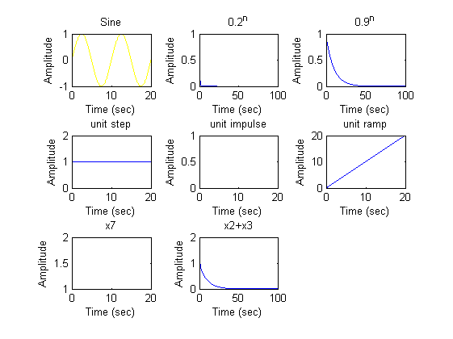

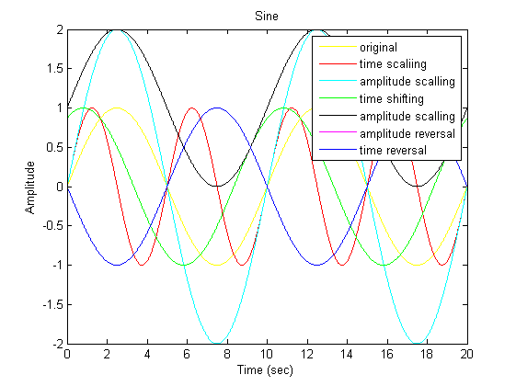

[*Published with MATLAB® R2014a*](http://www.mathworks.com/products/matlab)

Impulse function

function x5=impls1(tt)

for i=1:length(tt)

if(tt(i)==0)

x5(i)=1;

else

x5(i)=0;

end

end

end

Step function:-

function xe=step1(tt)

for i=1:length(tt)

if(tt(i)>=0)

xe(i)=1;

else

xe(i)=0;

end

end

end

Ramp signal:-

function xa=ramp1(tt)

for i=1:length(tt)

if(tt(i)>=0)

xa(i)=tt(i);

else

xa(i)=0;

end

end

end

**OBSERVATION:-**

**All the graphs have been displayed and parameters are verified.**

**CONCLUSION:-**

**All operations in different signals were executed.**